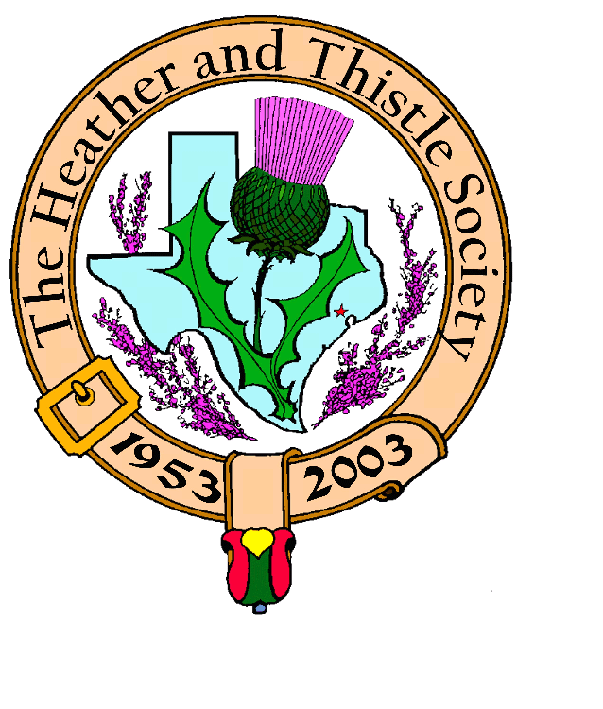

Heather & Thistle Society

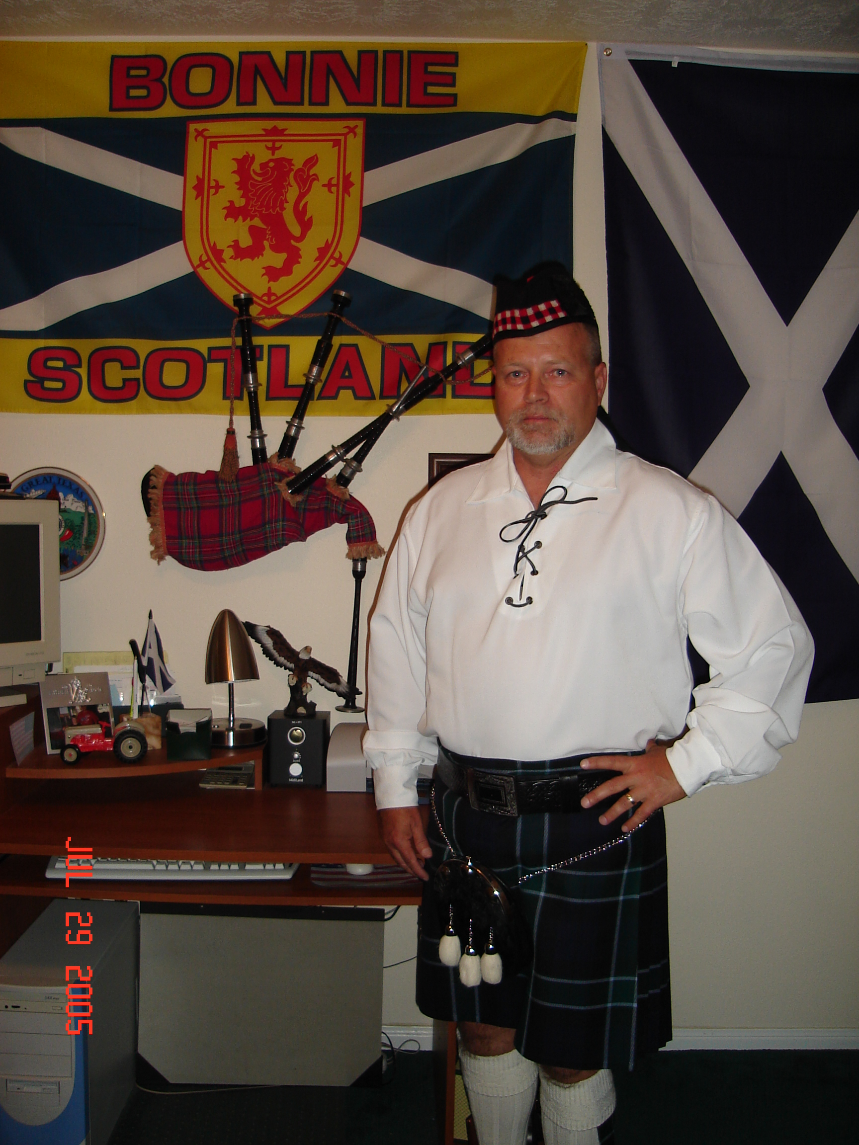
Chieftain Jim Monteith

Volume 7, Issue 3
November, 2006

Newsletter Editor:
Jim Monteith

Officers:

Chieftain – Jim Monteith
Sub-Chieftain – Ken Sorrels
Sgt.-at-Arms – Chuck Monteith
Secretary - Sharon Monteith Treasurer - Robert Moore

Committee Chairs:

Sunshine-Eileen Moore
Membership-Eileen Moore
Past Chieftains-vacant
Burns Supper-Walter May & Becci Himes
Publicity-Melvyn Douglass
Programs-Cheryl May



The Houston Scot

Chieftain’s Letter,

We had a great turnout at the October 23 meeting. Twenty eight members and nineteen guests enjoyed the Scottish Folk Music of Ed Miller. I cannot thank Mark Monroe enough for providing us with such quality programs.

Many thanks to Past Chieftain Jack Hume for getting the Society’s Washington Mutual bank account straightened out. The account had been originally set up many years ago and there was no monthly fee charged. In October 2005 they started charging a fee. The account has been closed and a new Free Business Account has been set up. The bank has reimbursed the Society for four months.

I hope everyone is ready for Scottish Country Dancing at our November, 2006 meeting on the 27th. The RSCDS (Royal Scottish Country Dance Society) will be teaching us their steps once again.

I am hoping for a good member turnout at our annual Kirkin O’ the Tartans to be held Nov. 12, 2006 at 10:30am at St. Paul’s Presbyterian Church located at 7400 Bellaire Blvd., Houston. Bill Robertson, of the Houston Highlanders Pipe and Drum Band has graciously agreed to pipe for the event. Members, please contact your Chieftain soon at 281-924-3073 (cell) or email him at alabamascotsman@esagelink.com and let him know if you are attending. We need a head count for the Chinese buffet at the Church after the Kirking Service. I am told the buffet will be available for three dollars or so.

I am trying to keep it short this month so I can put some more stuff on this page.

Chieftain Jim Monteith

St. Andrews Day Celebration to be held Nov. 30, 2006 at the Black Lab, Churchill Room, 4100 Montrose Blvd., Houston. Hosted by the Houston Grampian Association, the event will start at 6:00 pm. In Honor of the patron Saint of Scotland, Scottish libations, and bar suppers, with a Scottish flavour, will be available for purchase. Ian Martin, of the Houston Highlanders will be piping. All Welcome!

2007 Burns Supper

Tickets on sale now!!!!!!!!!!!!!!!!!!!!!!! Fill out order form on page 3 of this newsletter and mail today before it’s too late!!!!!!!!!!!!!!!

Heather & Thistle Society presents the 54rd Burns Supper to be held on Saturday, January 27, 2007 at the Houston Marriott Westchase, 2900 Briarpark Drive, Houston, Texas.

Musical performances by The Houston Highlanders Pipe Band and The Saint Thomas Episcopal School Pipe Band.

Dance performances by The Royal Scottish Country Dance Society and The Saint Thomas Episcopal School Highland Dancers.

Scottish Historical Events
For November

Nov. 1, 1884 – Gaelic Athletic Association founded.
Nov. 2, 1853 – Association for the Vindication of Scottish Rights (a home rule organization) founded in Edinburgh.
Nov. 4, 1698 – Foundation of Scotland’s only New World colony, New Caledonia, at Darien, Isthmus of Panama.
Nov. 7, 1974 – Eric Linklater, Scottish novelist, born in Wales, author of The Survival of Scotland, died.
Nov. 8, 1745 – Charles Edward Stuart invaded England at head of a Jacobite army.
Nov. 8, 1752 – James Stewart of the Glen, Scottish Jacobite, executed by English after wrongful conviction for murder of Colin Campbell of Glenure.
Nov. 13, 1850 – Robert Louis Stevenson, Scottish author, born.
Nov. 14, 1797 – Charles Lyell, Scottish founder of modern geology and mentor of Darwin, born.
Nov. 16, 1745 – English army sets out from Newcastle in vain attempt to stop Scottish Jacobite invasion of England.
Nov. 17, 1745 – James VII of Scotland proclaimed King on English soil as James III.
Nov. 21, 1638 – General Assembly of the Faithful meets in Glasgow without representation of religious hierarchy.
Nov. 23, 1847 – Walter Biggar Blaikie, Scottish historian, born.
Nov. 23, 1909 – Nigel Tranter, Scottish historical novelist, born.
Nov. 24, 1996 – Sorley Maclean, Scottish Gaelic poet, died.
Nov. 26, 1836 – John London McAdam, Scottish engineer who developed the macadam road, died.
Nov. 28, 1666 – Battle of Rullion Green, Scotland
Nov. 30 – Saint Andrew’s Day – the patron saint of Scotland
Nov. 30, 1990 – Scottish Constitutional Convention produces plan for a Scottish legislature.

Heather & Thistle Society – Minutes
October 23, 2006

Our program tonight was a musical performance by Scottish Folk Singer, Ed Miller. Mr. Miller played a variety of traditional folk music from all over Scotland and provided historical commentary about the revival of Scottish Folk Music. Once again, thanks to member Mark Monroe for arranging Mr. Miller’s performance.

Chieftain Monteith called the business meeting to order at 9:02 pm in the auditorium of the St. Thomas Episcopal School. Motion was made to accept the September, 2006 minutes as published in the newsletter.
Treasurer Report: No report.
Membership Report: No report.

Committee Reports called for by Sub-Chieftain Ken Sorrels.

Burns Club: Ted Hirtz reports they are working on their January 2007 presentation which may be performed in English.
Burns Supper: Cheryl May reports they received the raffle tickets from Continental Airlines. St. Thomas Pipe Band performance at the Supper has been confirmed. Bob Gilbert will be our speaker this year for the Immortal Memory. Jim Walter will be providing the Haggis and performing the Haggis Ceremony. Next meeting will be on Nov. 7, 2006.
Past Chieftains: No report.
Programs: Cheryl May thanked Mark Monroe for scheduling the last two programs. Scottish dancing will be our program at the November 2006 meeting. December 2006 will be our annual Christmas Party. The January 2007 program will be a performance by the Burns Club.
Sunshine: No report.
Newsletter: Editor Jim Monteith reports nearly 70 members have not renewed their memberships and have been dropped from the newsletter mail out list.
Houston Grampian: Cheryl May thanked H&T Society for helping out with the Aberdeen visitors. Ken and BJ Sorrels and Chuck Monteith got the tartans to the Burns Memorial Bust for a ceremony. Ken Sorrels also gave a tour of his Chiropractic College to some of the visiting nurses. The send off dinner was very successful and had a Western theme.
Houston Highland Games: Scheduled for May 11, 12, and 13th of 2007.
RSCDS: Ted Hirtz reports Carol Palmer put on a dancing workshop at Rice University. They had a formal ball and had lots of fun.
Houston Highlanders: No report.

Sergeant-At-Arms Chuck Monteith reports 28 members present and 19 guests.
Old Business: None.
New Business: Chieftain Monteith reports that the H&T storage facility was broken into a few weeks ago. The lock was cut. Nothing appears to have been taken. The Chieftain bought a new lock for the room. Storage facility management advised the Chieftain that 12 units were broken into in one night and power tools were stolen.
November 2006 meeting will be on the fourth Monday of the month, the 27th.

Meeting adjourned at 9:17 PM.

Clan Munro Gathering Planned In Scotland

Clan Munro USA held its annual fall meeting in Albany, N.Y., and plans were announced for the 2007 Gathering to be held in Scotland. 2007 is the 70th anniversary of the founding of Clan Munro and the two day event will be held over the week-end of July 28-29 in Inverness. Heather and Thistle Society members, Mark A. Monroe of Houston, and Coleen Johnson of Kerrville, attended the Albany Gathering.

The Heather and Thistle Society
54rd Annual Robert Burns Supper
Saturday, January 27, 2007
Houston Marriott Westchase , 2900 Briarpark Drive, Houston, TX 77042
Ticket Order Form
Name of Ticket Holder * | No. Tickets | Total # Member Tickets @ $55 | Total # Non-Member Tickets @ $70 | Total Dollar Amount
Mail to:
Name:
Address:
City |  | State |  | Zip
Phone # |  | E-mail
* Member tickets may be purchased by/for only those with current dues as of September 30, 2006. Tickets ordered in November must be paid for in full by December 1st. Please list names for whom member tickets are requested. Use a separate sheet for each table of ten.
Enclose a self-addressed, stamped envelope with this form and your check made payable to the Heather and Thistle Society. Mail to:
 | Mrs. Robert A. McClure (Joan)
 | 553 Brown Saddle Road
 | Houston, TX 77057-1413
 | Ph: 713-782-6707
Date received |  | Ticket Nos. | Table Nos. | Tickets Mailed
__________________ |  | _________________ | _________________ | _______________

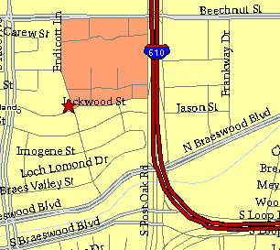

Meeting Information

Meeting Place:
St. Thomas Episcopal School
4900 Jackwood
Houston, Texas 77096

Date and Time:

Fourth Monday of the month
7:30 pm

Heather & Thistle Society Statement
And Membership Information

The Heather and Thistle Society was founded in 1953 by Scots living in Houston who wished to “cultivate an interest in and fond recollections of Scotland, its history and traditions, its literature and ideals, its minstrelsy and song, its customs and amusements, and to provide opportunities for good fellowship and social contact through typically Scottish functions, so that the blessing of our Scottish culture may never die in our new homeland”.

The Heather and Thistle Society meets 10 times a year, September through June. Programs include music, singing, dancing, lively lectures, slide shows and movies about Scotland. The Heather and Thistle Society puts on the annual Robert Burn’s Supper and Ball in late January of each year. We are an organization that promotes our Scottish heritage, in various ways.

The Heather and Thistle Society’s monthly newsletter, “The Houston Scot” is published from September through June. Original articles, information about Scottish or related events are welcome and should be sent to the editor, Jim Monteith, at 15703 Mound Road, Hockley, Texas 77447 or 936-931-2588.

Membership in the Heather and Thistle Society is open to all with an interest in Scottish heritage and culture. Annual dues are $15 for an individual and $20 for a family membership. Applications for membership may be obtained from our website
http://heatherandthistle.org/documents/membership.doc
Dues are due at the beginning of the fiscal year, March 1. Completed applications and membership fees should be mailed to: Mrs. Eileen Graham Moore
8910 Sandstone, Houston, Texas 77036-6132
For membership information please call Eileen at 713-774-0314.



